POD Maths Homework
The Maths homework is due in on the day of return to school.
Please select complete the activities below during the time that school is closed.

Draw and describe 2D shapes around your home. Use the 2D shapes to create pictures e.g. animals, plants and moving objects such as trains, cars and planes.  Draw and describe 3d shapes around your home.  Remember to include:  -the number of vertices  -the number of edges  -the number of flat or curved surfaces.  Learn and draw 2D shapes and label the properties, such as the corners, sides and faces etc. | Learn and recall multiplication and division facts for all the times tables from 1-12 including the division facts.  Learn your 15 and 25-times tables and division facts.  Use this website to revise your knowledge of fractions and equivalent fractions:  http://www.topmarks.co.uk/flash.aspx?f=fractionsv7  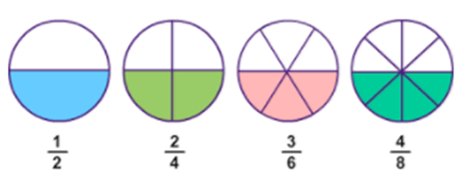 | Use the column/expanded column method to add and subtract two digit and three-digit numbers (including decimal numbers). Use the grid method/chunking method to multiply and divide numbers. Create some calculations of your own.  Learn the Roman Numerals and write the date of birth of your family members in Roman Numerals.
Practise estimating and measuring objects around your house in centimetres (cm) and metres (m).  Estimate the measurement of 6 objects, then measure them accurately and record your results in a grid.  Example:  Object Estimation Actual Measurement  Spoon 10cm 11cm | Practise telling the time on a clock, including o’clock, quarter-past, half-past and quarter-to.  Make a table and record the time when you:  -wake up  -eat your breakfast  -do your homework  -eat lunch  -practise your time tables  -eat dinner  -read a bedtime story. | Keep a daily weather diary by drawing a pictogram and adding symbols to represent the weather.  Example:  - Hot days (sun)  - Cold days (cloud)  - Rainy days (rain drops)
Try these websites at home:
https://www.bbc.co.uk/bitesize/subjects/zjxhfg8
https://www.topmarks.co.uk/maths-games/hit-the-button
https://nrich.maths.org/9084
Access the maths is fun website on: https://www.mathsisfun.com/ Consolidate your learning on money, measurement, data handling, decimals and fractions.

